Label Scan Test – Customer Information

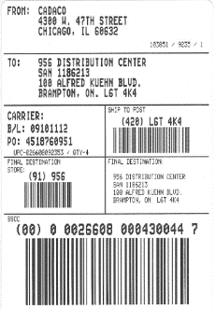
Please fill out all of the information on this form and mail the form, along with your actual shipping label (scanned copies are not allowed) to the following address.

WePrintBarcodes.com
683 Miamisburg-Centerville Road, Suite 212
Dayton, OH 45459
Actual Shipping
Label Required
Upon receipt, we will contact you for the $79.95 payment by credit card. Our customer service hours are 8:30 a.m. - 5:00 p.m. EST - M-F.

NOTE: Failure to send the form filled out in its entirety will cause significant delays to the Label Certification process.

Your Ship-to Information (Mandatory)
Company Name
Contact Name
Address
City/State/Zip
Phone
Email

Your Billing Information (If Different than Ship-to)
Company Name
Contact Name
Address
City/State/Zip
Phone
Email

Special Instructions

